Basic Info: It is always important to update the Basic information of any listing, this will make sure to boost the property accuracy, directly impact the business.
Below is the basic information required to update. However, we tend to miss:
- Geocode
- Name Formatting
- Postal Code

- Geocode: We express the physical location of each place with a set of coordinates (latitude/longitude), a point that can be represented on a map.
With traveler experience in mind, our goal for geocodes is to have front door accuracy. This means that the BEST geocode for a place is at the front door of the place on the map, however, if a listing already has a rooftop geocode that is confirmed to be correct, do not spend time moving the geocode to the front door of the place. Roof top accuracy/Front Door
Screenshot 1: While adding geocodes in the LMT verify the accurate pin point
po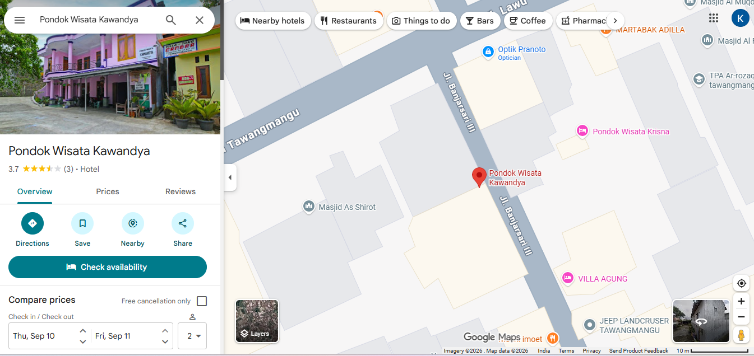
Screenshot 2: Error reason why it is not most accurate firstly & end up in a wrong geocodes
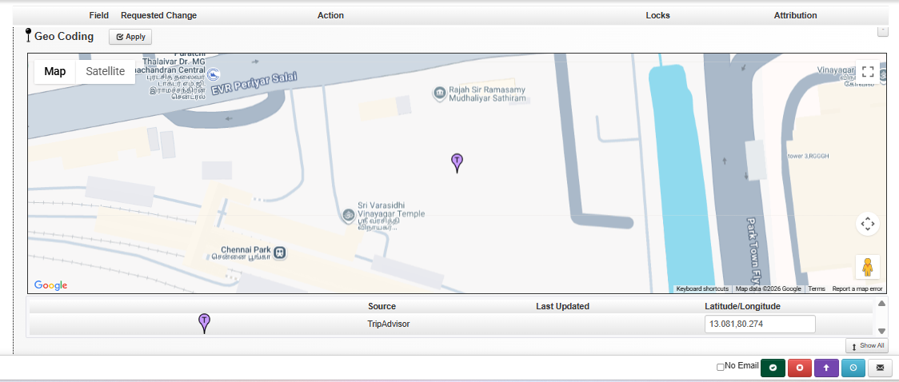
Screenshot 3: Add geocodes again for the accurate pin point in the tool for our listing
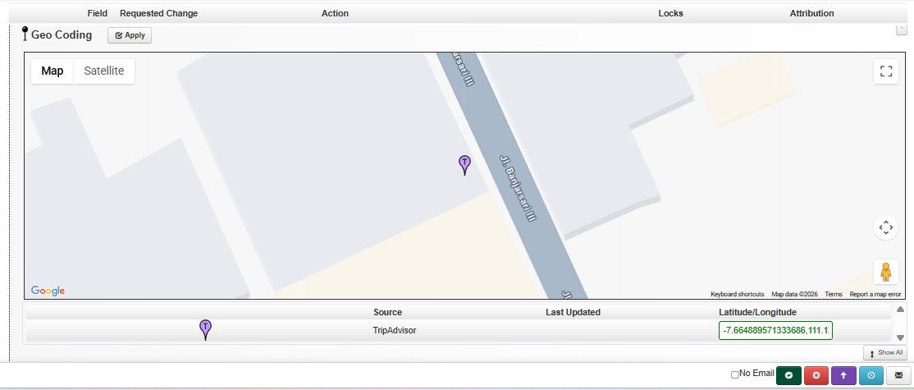

- Name Incorrect Formatting: Capitalization and formatting of Name and Street data should follow what is shown on the official source(s). Keep the hierarchy in mind!

- Postal Code: Follow the postal code standard for the country.
Postal code should NOT include:
- geo name
- extra spaces, dashes, or any other formatting that does not adhere to the country standard
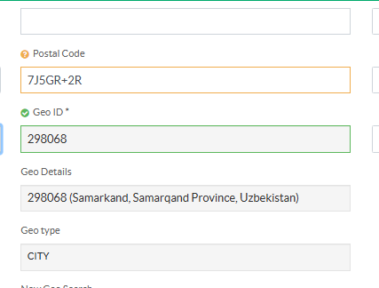

4. Listing Info: It is always important to update the listing information of any property so it can help viewers to know and understand the status and working hours of any business.
Below is the listing information that needs to be checked to make sure

- What if a place's hours are “Open from ____ until late”?
When the closing time is described as “until late,” save the closing time as 23:59—which is the latest it’s possible for our Hours module to go.
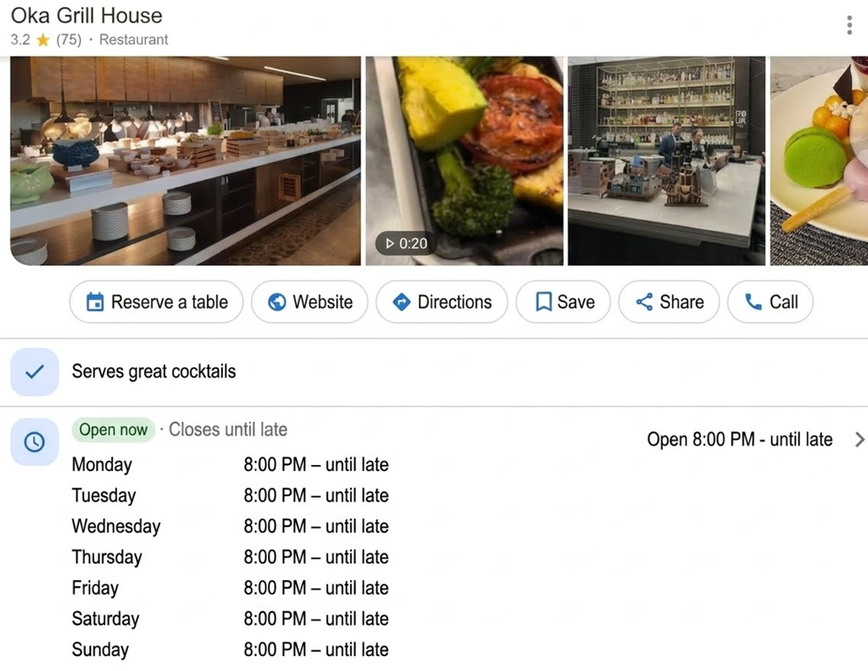

- What if a place's hours are "Always open"?
You should enter the time as 00:00 to 23:59.
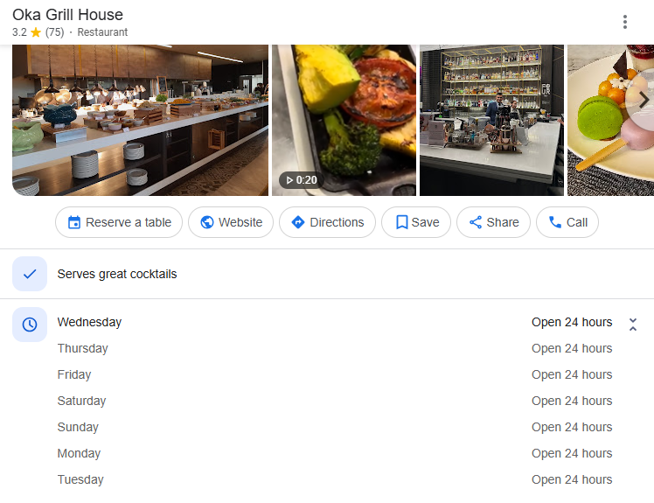

Missed Details:
- Phone Number:
1. Always remember to add phone number when available
2. Do not include extensions
3. Do not add Phone number belongs to different business or cannot be verified
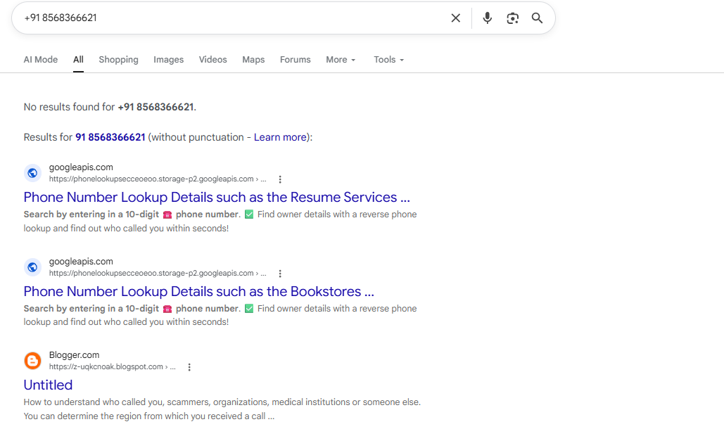
- URL Not added when available:
1. Most of time agents has missed the official website which is clearly visible on the Google Listing or Google search
Refer from the Google Listing & Google search for accurate information on our listing
Example:
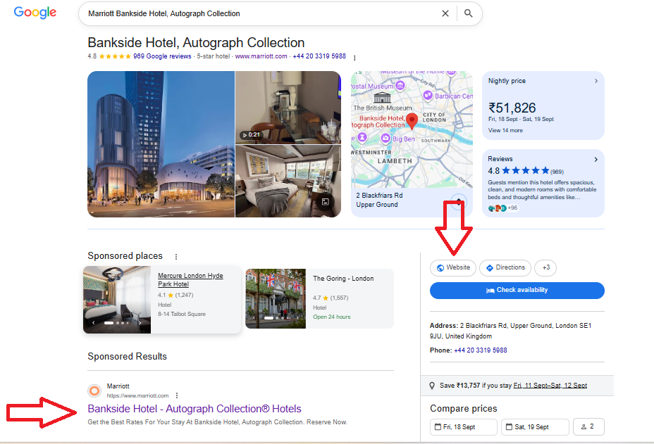
Major Fields:
a. Geo incorrect/non city level (agent saved or did not improve):
Always follow the correct process to identify the accurate geo for any listings regardless of which queue we are working on
For example, if we are listing the place named Travelodge Gloucester, the correct geo is Gloucester.
In the slide below, we can be reasonably sure Gloucester is the correct geo because left-clicking on the word Gloucester shows a red-dotted border.
The Travelodge Gloucester map pin is inside this border:
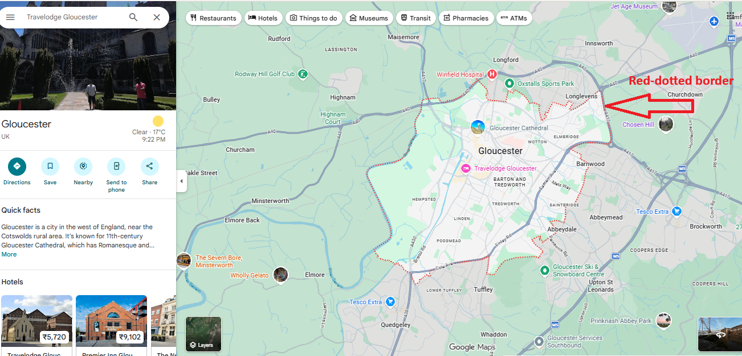
Search in the TripAdvisor system see if this exist in our system or not
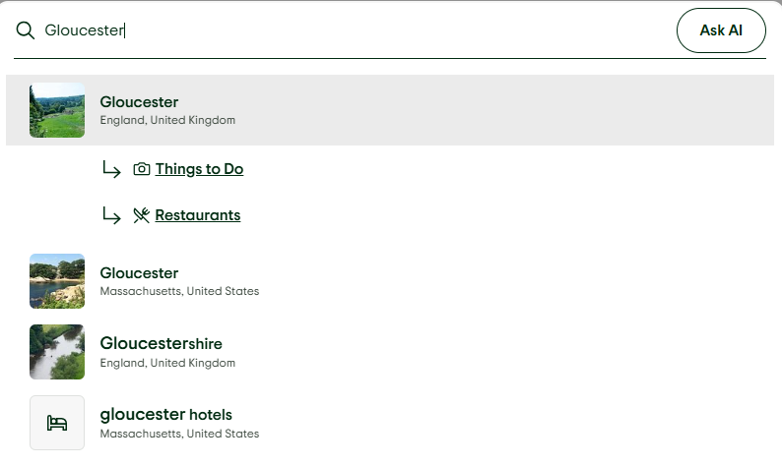
If you find the geo, enter the geo ID without the "g" into the New Geo Search field in Calypso or geo search box in the LMT.
Calypso will display the geo automatically, after entering the geo ID in the New Geo Search field, as seen below:
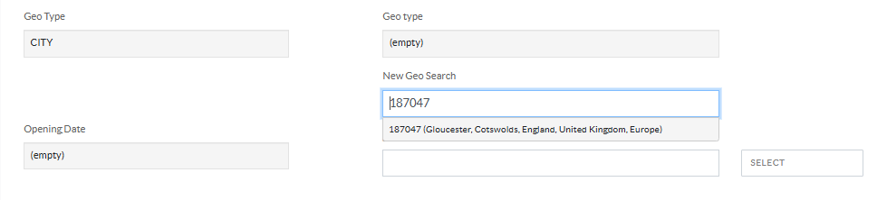
The LMT requires you to click the search button in geo search box, as seen below:
Invalid Action:
- Used Incorrect Rejection Reason:

Primary:
- Rejected Eligible Listing.
- Saved DMG listing (new listing)

Major Reasons for primary errors is due to incomplete research or not following the hierarchy of research tools.

Hierarchy of research sources :
